**Task 2: Writing BI plans with the BI Wizard**

**As you go through the BI Wizard, please use the following researcher profile as a case study to help you think through the questions.**

You do research in the Amazon and Asian Pacific rainforests on the acoustics of bird calls among tropical bird species. You are seeking NSF funding so that you and your grad students can travel to these rainforests with audio recording equipment to study and compare species and their calls. You will collect and analyze audio from as many species as possible. You also plan to compare these calls to those from several species found in the forests of the Pacific Northwest of the US, but you have not collected audio recordings of their calls yet, either, and do not have the resources (personnel and time) to collect calls from all of these areas during your three years of funding.

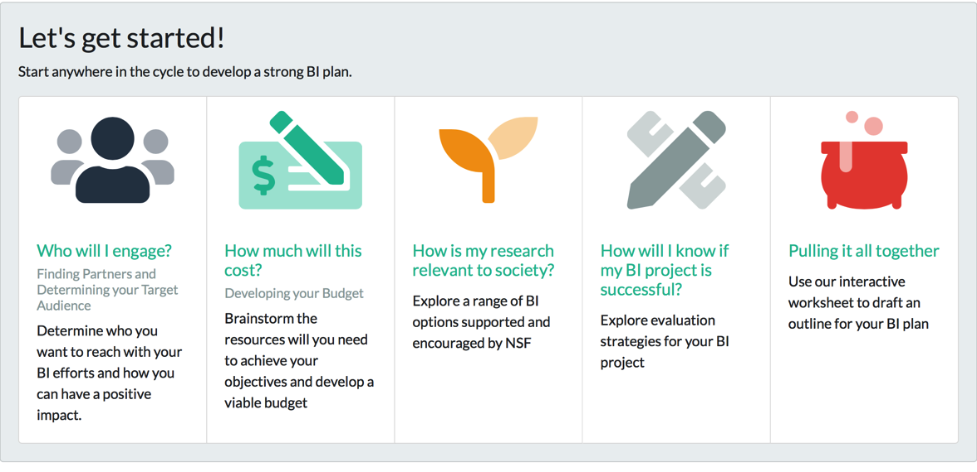Go to: <https://aris.marine.rutgers.edu/wizard/step0.php>. Then go to “Pulling it all together” and create an outline for your BI plan. Note, information is only saved locally in your web browser and is not shared with our server. You can only work on one BI project at a time. When you are done, you can copy all your work from the [summary](https://aris.marine.rutgers.edu/wizard/summary.php) page. This will give you the notes you need to continue your work on the BI elements of your actual proposal.

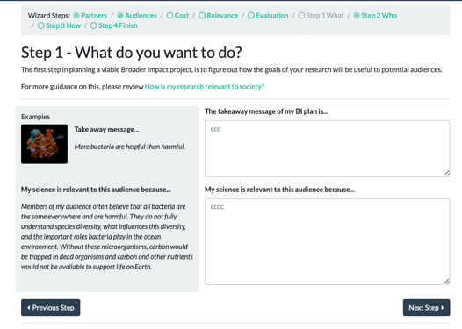**Step 1 – Relevance: Start with the end goal first (Backwards Design).**

This page allows you to articulate what is important about your research and how it might be relevant to the audience you have selected.

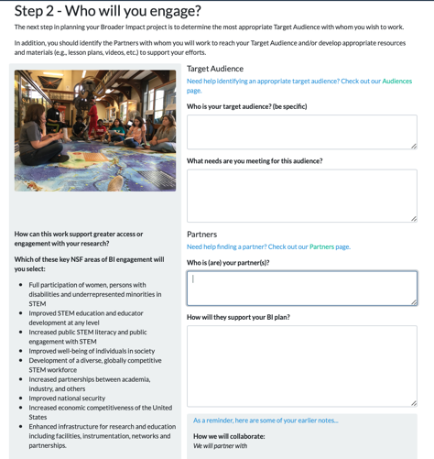

**Step 2 – Who will you engage?**

You can click on audience link to select audience type and then go back to Summary to see literature link.

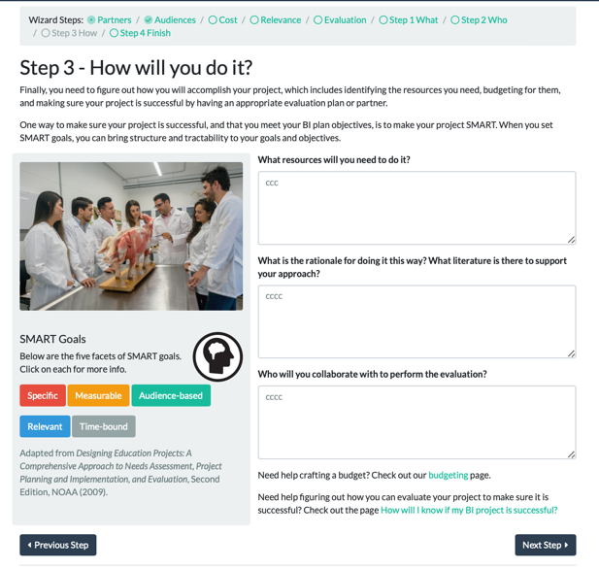

**Step 3: How will you do it?**

In this section, you will write about how you will accomplish your project, which includes identifying the resources you need, budgeting for them, and making sure your project is successful by having an appropriate evaluation plan or partner. Use the SMART too to make sure your objectives are Specific, Measurable, Action-based, Relevant, and Time-bound.

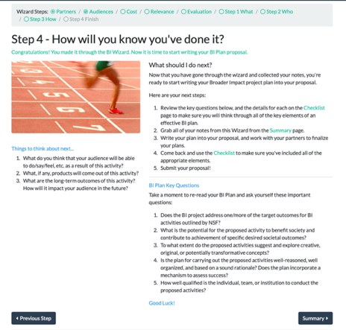**Step 4 & 5: How will you know you have done it?**

In this step, you are encouraged to re-read your BI Plan (which you can find on the Summary page) and ask yourself these important questions:

* Does the BI project address one/more of the target outcomes for BI activities outlined by NSF?
* What is the potential for the proposed activity to benefit society and contribute to achievement of specific desired societal outcomes?
* To what extent do the proposed activities suggest and explore creative, original, or potentially transformative concepts?
* Is the plan for carrying out the proposed activities well-reasoned, well organized, and based on a sound rationale?
* Does the plan incorporate a mechanism to assess success?
* How well qualified is the individual, team, or institution to conduct the proposed activities?

**Final Summary Page**

***Print your Summary page as a pdf and upload it for our group discussion.***